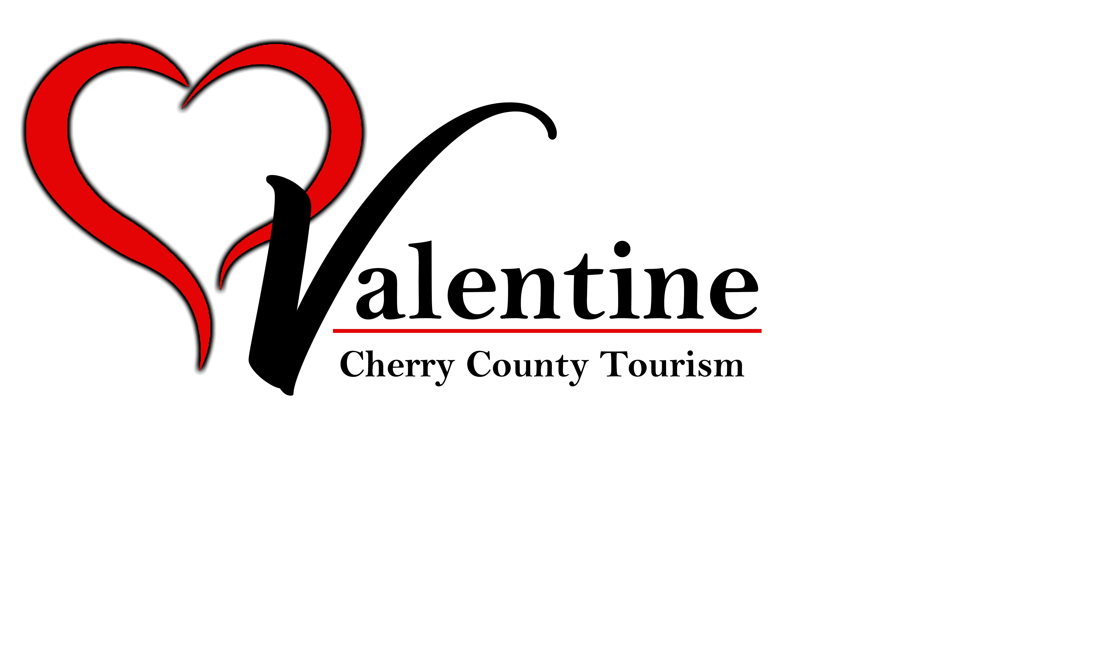
Cherry County Tourism Board

2021-2022

Tourism Grant Guidelines And Application
Deadlines

Cherry County Tourism grant applications will only be reviewed on a quarterly basis: at the monthly meetings in January, April, July and October.

- January – For events occurring in April, May and June;
- April – For events occurring in July, August and September;
- July – For events occurring in October, November and December;
- October - For events occurring in January, February and March;

2021-2022
Tourism Grant Guidelines And Application

The role of the Cherry County Tourism Board is to serve as a catalyst for tourism development and promotion. We will be a proactive leader among community organizations and help create collaborative solutions to identify and market the best of the Sandhills and its heritage to visitors.

One of the ways the Cherry County Tourism fulfills this mission is to offer grant applications to businesses and community organizations to assist them in hosting and promoting events and attractions. Grants will only be reviewed on a quarterly basis: a special grant review meeting will be held the 3rd Tuesday of the month in January, April, July and October @ 2:00 at the Valentine Visitor Center.

There are three types of grants available from Cherry County Tourism:
- COMMUNITY EVENTS - 1 DAY / 2 + DAYS
  - 1A. One Day. Grants available up to $1000.00 Funds will be used for promotion, qualified expenses of event, and support the sustainability, hosting capacity and expansion of local festivals/events within Cherry County. Event participants will come from a 1 to 100 mile radius of Cherry County. Twenty-five percent, 25%, of grant must be used for promotion of event.
  - 1B. Two plus days. Grants available up to $4000.00 Funds will be used for promotion, qualified expenses of event and to encourage and attract visitors to come to Cherry County and use the facilities within the county. Event participants will come from a 100 mile plus radius of Cherry County. Fifty percent, 50% of grant must be used for promotion of event. Promotional advertising must reach participants/visitors outside of a 100 mile radius of Cherry County. Higher consideration will be given to grants that use innovative outreach and advertising to increase overnight lodging in Cherry County.

- EDUCATIONAL/CONFERENCE
  - Grants available up to $750.00 Funds will be used to support the growth of an individual through education in the tourism and hospitality industry. This education will help enhance marketing knowledge to encourage expansion of tourism in Cherry County. Example: Tourism conference attendance, classes for marketing within the tourism and hospitality industry.

- TOURISM ATTRACTION DEVELOPMENT AND IMPROVEMENT
  - Grants available greater than $4,000.00 Funds will be used for entities that want to develop tourist attractions in Cherry County. The goal is to make Cherry County a destination area. A business plan with budget, marketing and goals would be required.

These grants are available to both for-profit entities and non-profit organizations. Grant approval is determined by the board and subject to funds available. Grants from the Cherry County Tourism are reimbursement grants. Organizations must submit invoices and proof of payment to be reimbursed for all expenses associated with approved grant. Upon submission and approval of these forms and final report, reimbursement will be made.

Purpose of Funds
The funds available through this program are provided from the lodging tax revenue fund and are to be used for activities and/or the development of an attraction. They should promote, encourage and attract visitors to Cherry County Nebraska as the state statute §81-3701 through 81-3729 provides. Higher consideration will be given to grants that use innovative outreach and advertising to achieve that goal. Visitor events and festivals must be in a defined location and open to the public. Grant funded events must be of educational, cultural, historical, artistic, entertainment or recreational significance or value.

Generation of room nights
Though tourism spending benefits all segments of the economy in Cherry County, lodging taxes are only generated through overnight stays at lodging properties located within the county. Applicants are encouraged to show how their project will generate additional night stays within Cherry County hotels/motels, campgrounds and RV sites, cabins, and AirBNBs.

Applications
Applications must be filled out completely and on time. The Cherry County Tourism Director at the Valentine Visitor Center will return all incomplete applications to the applicant for correction of any deficiencies. Staff is always available to answer questions and to assist in the application process.
It is recommended, but not required, that the applicants be present at the Cherry County Tourism Promotion Board meeting at which their application is reviewed. Board meetings generally occur on the 1st Tuesday of the scheduled month at 2:00 PM. A special grant review meeting will be held on the 3rd Tuesday of the months of January, April, July, October. Each applicant will be asked to attend and present their grant application.
Applicants will be contacted on the Friday prior to the Board meeting with presentation times. Presentations will begin at 2:00 P.M and will include a five minute break between presentations.

Applicants must limit their presentation to 10 minutes, allowing time for additional questions from the Cherry County Tourism Board. It is strongly suggested that the presentations be divided into five minutes for an overview of the project, including past and projected attendance numbers and a brief synopsis of the activities of the event, and five minutes for details of the budget and how any money awarded will be spent.

Exclusions
No part of the grant funds may be used for general operating expenses, for additional or current personnel salaries or in any manner that would violate the Nebraska Development Act, Neb. Rev. Stat. §81-3701 through 81-3724, et seq. (as amended from time to time). All grants are discretionary, based upon available funds, other anticipated uses, appropriateness and anticipated effectiveness of proposed use.
Events will be ineligible for funding if not all local and state permits are obtained.

Crediting Requirements
Included on all printed material, or advertising media shall be the words “sponsored in part by Cherry County Tourism”. Logos are available for download from VisitValentine.org or from the Executive Director @ the Valentine Visitors Center. Applicants will be directed to the appropriate logo.

Announcement of Award
All applicants will be notified in writing within ten working days after the review of the application with the decision as to their application.

Reporting, Accounting and Payment Procedures

Reporting
Forty-five days after the grant activities are completed the grantee must submit a report giving final results to the Cherry County Tourism Director @ the Valenine Visitors Centerlocated at 239 S. Main street, or by mail to
P.O. Box 687 Valentine, NE 69201. The report must outline if the objectives of the event were met, if not, what were the circumstances that lead to the deficiency.

Please refer to page 8 to find the Final Report outline. This is the guideline for your follow up report.

Final reports MUST include paid invoices and copies of proof of payment. Proof of payment may be copies of canceled checks, credit card receipts or copies of bank statements with confidential information redacted. No cash receipts will be accepted for reimbursement

Final reports and documentation not submitted within 90 days after the end of the event or the completion of the promotion project will be considered delinquent and the grant award will be forfeited.

Payment
Upon receipt of the final report and all required accounting documents, the Cherry County Tourism Board will request a check from the Cherry County Treasurer for the grant funds. This check will be sent by the Treasurer directly to the grantee. The check will come from the Cherry County Treasurer.

Review Process
Grants are discretionary, based upon available funds, other anticipated uses, appropriateness and anticipated effectiveness of proposed use all in compliance with the Nebraska Revised Statute §81-3701 through 81-3724.

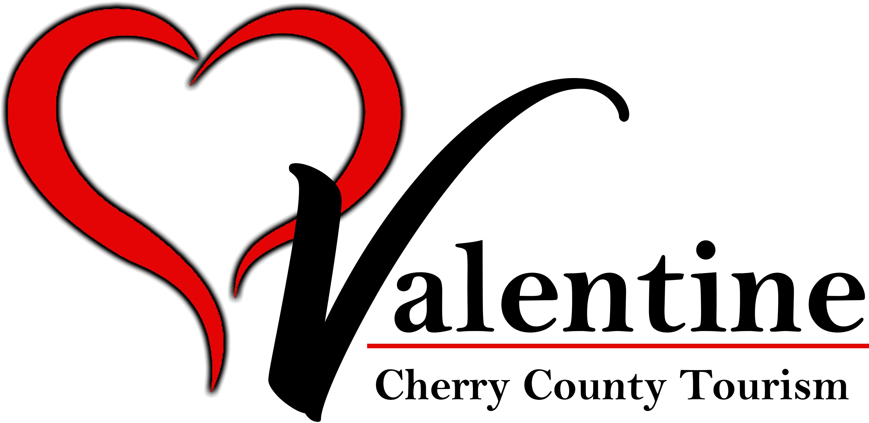

GRANT APPLICATION TODAY’S DATE: / /

Which Grant are you applying for? (Check all that apply)
- Community Event Grant– One day
- Community Event Grant – Two Plus Days
- Educational/Conference
- Tourism Attraction Development and Improvement

Name of Organization  Contact Person  Address/City/State/Zip Name award check should be made out to: Address check should be mailed: Phone Mobile  Name of Event  Total Grant Funds Requested: $  Please provide a brief description of the project: | Title
 | Email
 | Date of Event

Checklist - For each grant application you must include: This completed cover sheet.
Project narrative pages - answering corresponding grant questions on page 6. Budget page. (Business Plan if required)
Return to:
By mail - Cherry County Tourism, P.O. Box 687, Valentine, NE 69201.
In person - Valentine Visitor Center 239 S. Main Street, Valentine. For more information call (402) 376-2969

Project narrative
Please include answers to questions below that refer to the grant you are applying for.
Remember, the goal of Cherry County Tourism, is to increase non-local visitors to the Cherry County area.
Target markets must reach outside of the local area that you are promoting.

Questions for Educational/Conference grants only.
- How will the opportunity benefit Cherry County?
- What other agencies/groups are co-sponsoring your attendance to this event?
- What kind of conference/event do you plan to attend? Who are the keynote speakers?
- What are the expenses to attend the event?
- What is your goal in developing tourism in Cherry County?

All other grant applicants must answer the following questions 1 - 6.
- What is your event and how it will benefit Cherry County?
- What other agencies or groups are co-sponsoring this event?
- Who is the target market for this event?
- How will your event/area be marketed? (1-100 miles in) or (100 plus miles outside of area)
- How many people do you expect to attend and how many nights lodging will be required?
- Has this project received funding through the Cherry County Tourism in the past? If yes, when and how much?

Community Events: Two plus Days grant applicants must answer the additional questions 7-11.
- What is the previous attendance of the event?
- Where do your participants come from?
- What are your goals and objectives and strategy for ensuring an event success?
- How will you measure the success of the event?
- Organizations must show impact across a broad segment of the community as well as plans for sustainability. Also, you may be asked to provide evidence of sound financial management, strong leadership and an engaged governing board.

Tourism Attraction Development and Improvement must answer questions 7-11 and provide the following:
  - Business Plan
  - Goals & Objectives
  - References
  - Letter of Recommendation from a banking institution

If you have any questions regarding which grant applies to your event or need assistance with the the application process, please contact the Cherry County Tourism Director @ 402-376-2969 or stop by the Visitor Center office @ 239 S. Main Street in Valentine.

BUDGET WORKSHEET

- Please include coverage maps of all broadcast and print media purchases to show reach outside Cherry County
- Use additional sheet of paper if necessary

PROMOTIONAL ACTIVITIES
Activity Grant Request

Brochure/poster design, printing, distribution |  | $
Social Media |  | $
Radio (list stations): |  | $
TV (list stations): |  | $
Newspapers (list publications): |  | $
Direct Mail |  | $
Website |  | $
Other: |  | $
Other: |  | $
Other: |  | $

ADDITIONAL HOSTING EXPENSES
Activity Grant Request

$
$
$
$
$
$
$
$
$
$
$
$
$
TOTALS FOR PROMOTION + HOSTING EXPENSES

Page 7 of 8
Total Grant Funds Requested: $

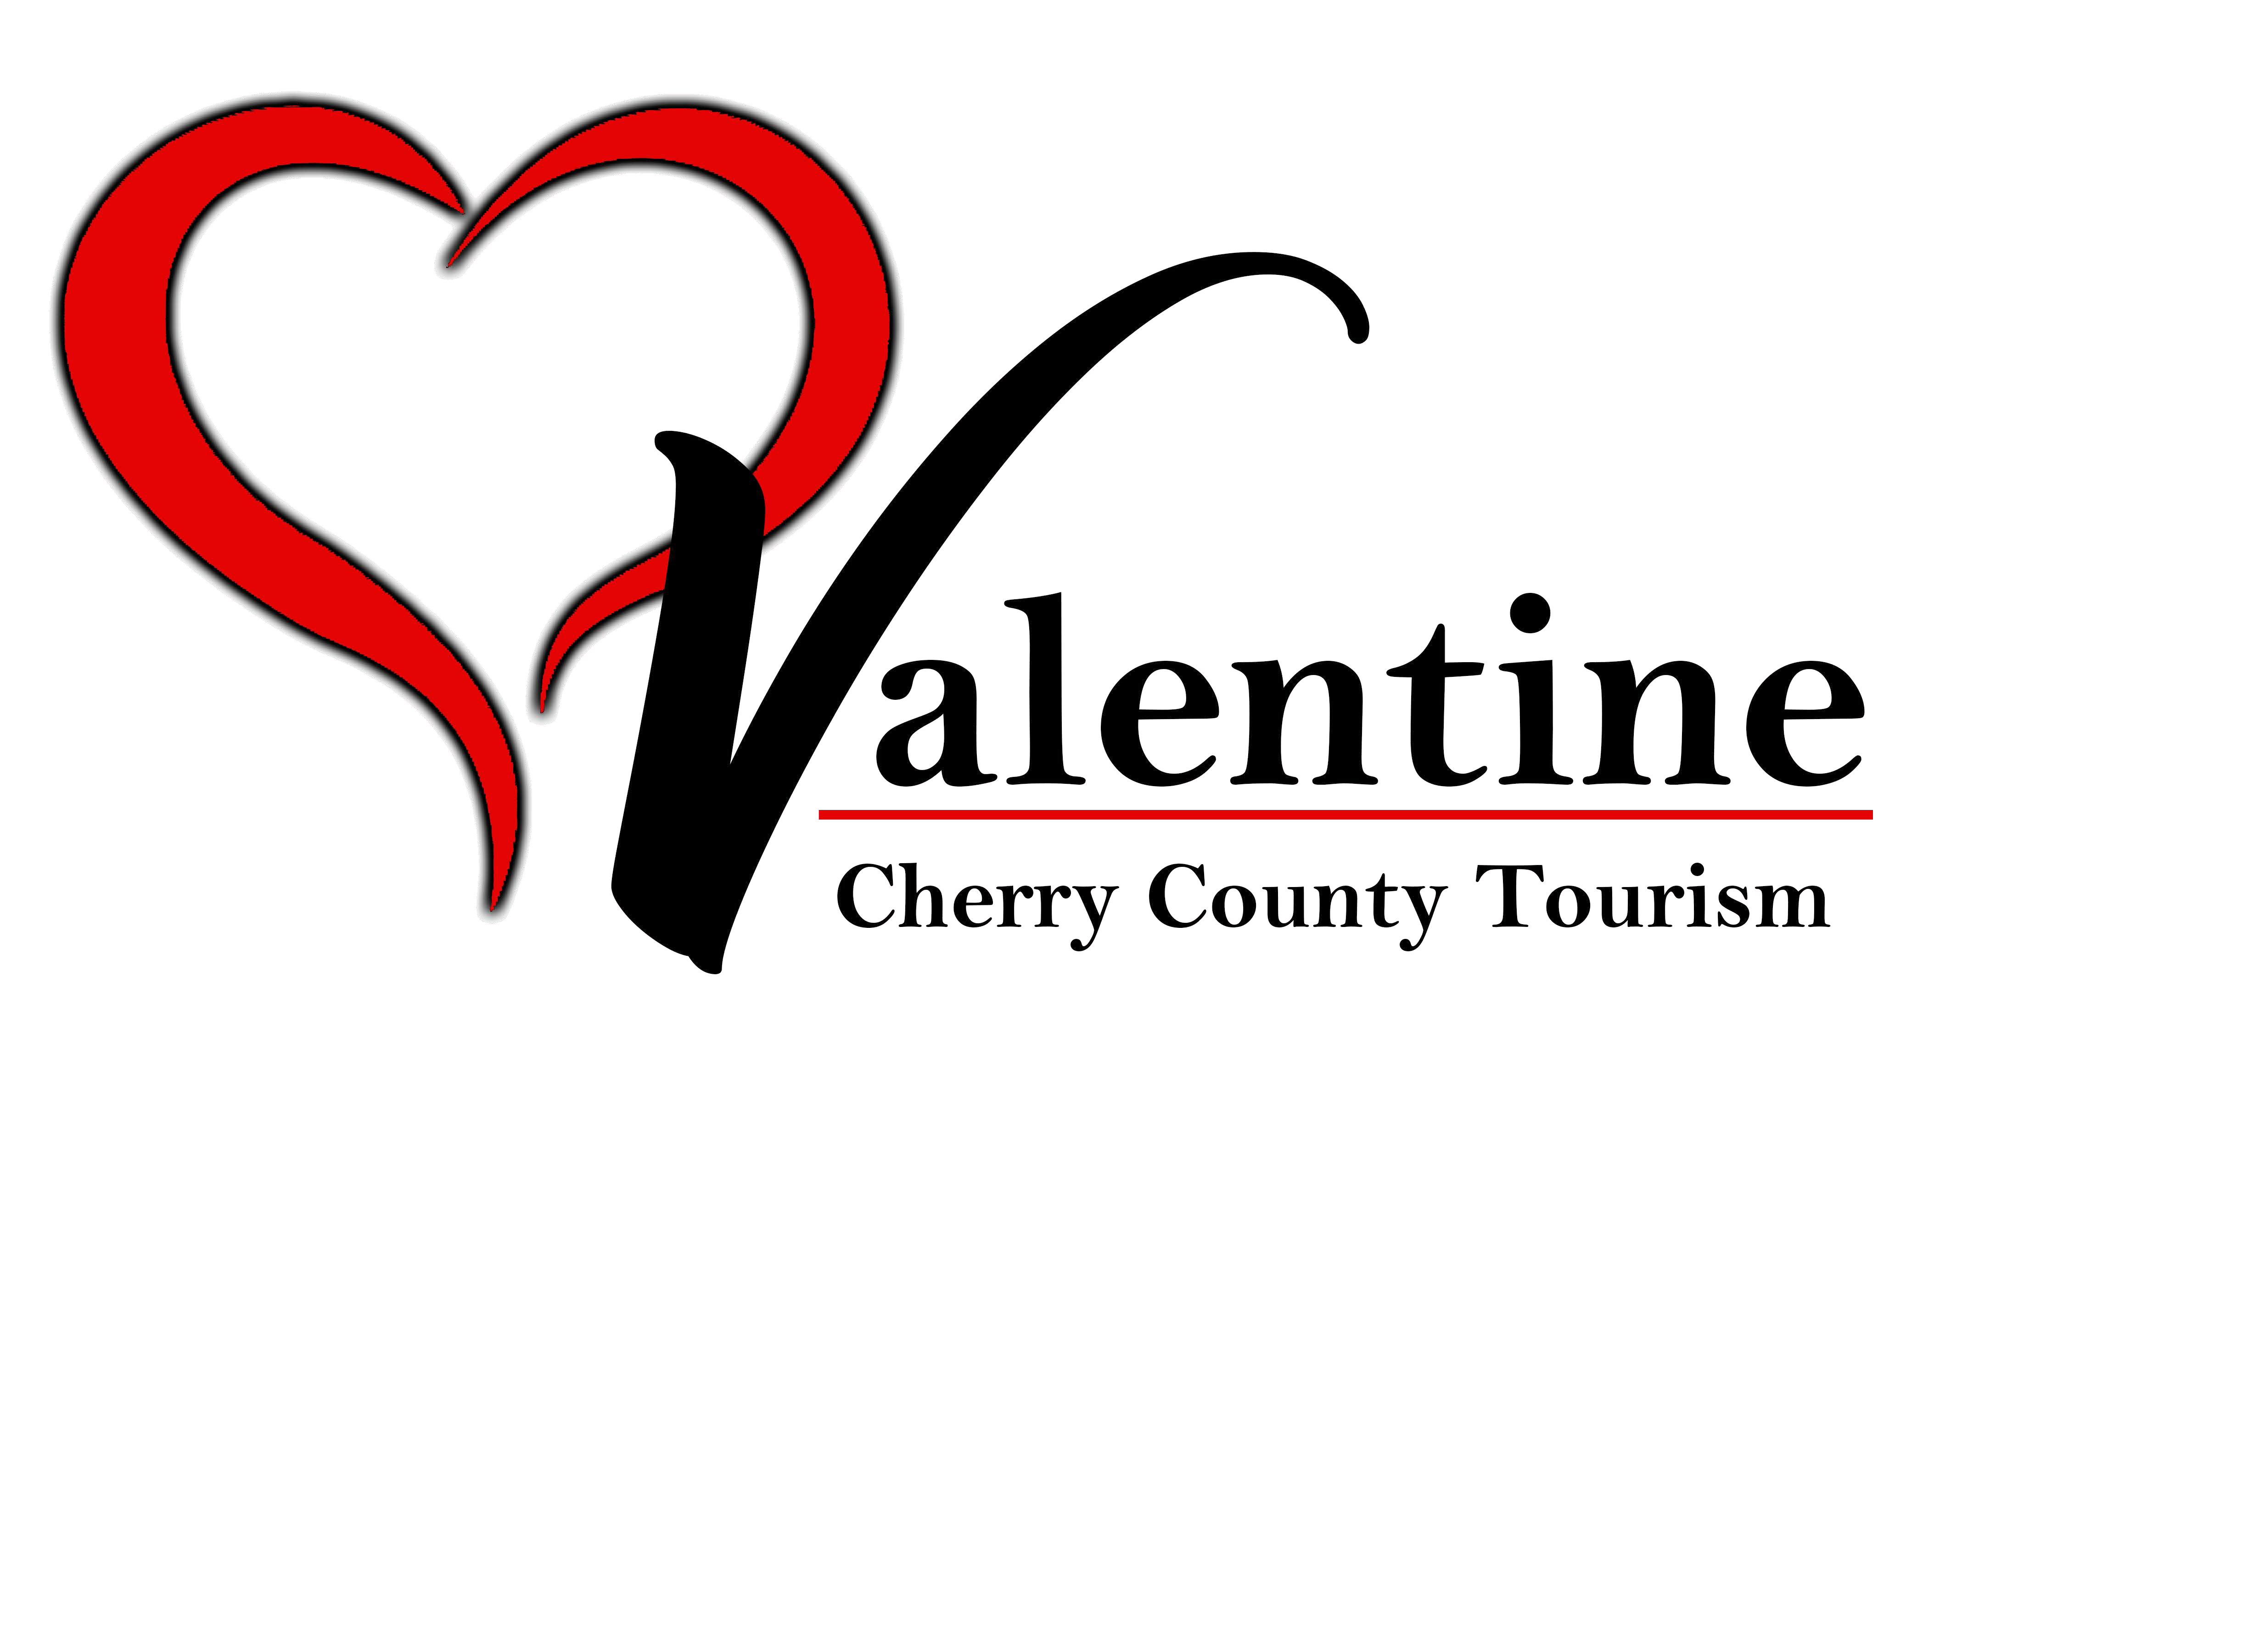

Final Report

Community Events
Tourism Attraction Development and Improvement Educational/Conference
Once your project is complete, submit your final report within 45 days after the completion of the project/event. Final reports and documentation not submitted within 90 days after the end of the event or the completion of the promotion project will be considered delinquent and the grant award will be forfeited.

Final reports for Community Events and Tourism Attraction and Improvement must include all of the following:
- Complete a request for reimbursement cover page.
- Include copies of vendor invoices and proof of payment: copies of cleared checks and/or paid invoices showing the actual costs incurred.
- Final Project Report of not more than three pages including the following items:
  - Synopsis of the project
    - Description of the project
    - Were the objectives for this project met? If not, what were the circumstances that led to the deficiency?
    - Do you intend to continue this event and what changes will you make to increase attendance?
    - Final lodging numbers (room nights)
    - Final attendance numbers
  - How grant funds were used in addition to the above requests.
  - Measurements of marketing effectiveness and impact (attendance counts, number of advertising- stimulated inquiries, etc.)
- Copies of Print, audio, and digital advertisements including reference to sponsorship credit to Cherry County Tourism.

Final reports for Educational/Conference grants must include all of the following:
- Please give a brief synopsis of the event and how it benefited you.
- What specific information did you gain from attending this event?
- How will this information help you and/or your business with your tourism goal to advance tourism in Cherry County?
- Provide at least 4 people you met at this event and the resource that they can provide you to assist you in your tourism goal.
- Include copies of vendor invoices and proof of payment: copies of cleared checks and/or paid invoices showing the actual costs incurred.

Grant funds will be awarded after final report is approved by the Cherry County Tourism Board
Page 8 of 8

